Abstract: Employee attrition is an important challenge for organizations because the unexpected departure of employees can affect productivity, operational efficiency, and organizational performance. Predicting employee attrition using machine learning can help identify employees who may be at risk of leaving and provide useful insights into workforce management.
This study presents a machine learning-based approach for predicting employee attrition using an employee dataset containing 1,470 records. The study follows an end-to-end machine learning methodology involving data preprocessing, exploratory data analysis, feature engineering, handling of class imbalance, feature scaling, model development, validation, and evaluation. Constant features such as Over18, StandardHours, and EmployeeCount were removed because they contained no useful variation. Additional features, including CurrentRoleTenureRatio, PromotionGapRatio, and TenureGroup, were created to improve the representation of employee characteristics.
Five classification algorithms—Logistic Regression, Decision Tree, Random Forest, Support Vector Machine (SVM), and Naive Bayes—were trained and compared using Accuracy, Precision, Recall, and F1-Score. Hyperparameter tuning was subsequently performed on Logistic Regression using GridSearchCV. The best parameters were found to be C = 0.01 and solver = liblinear, producing a cross-validation F1-Score of 0.7917.

The tuned Logistic Regression model was selected as the final model based on its improved predictive performance. The study also demonstrates prediction on new employee information, showing how the developed model can be used to estimate employee attrition.
Keywords
Employee Attrition, Machine Learning, Classification, Logistic Regression, Decision Tree, Random Forest, Support Vector Machine, Naive Bayes, Feature Engineering, Class Imbalance, Hyperparameter Tuning, GridSearchCV
Introduction
Employee attrition refers to the process through which employees leave an organization voluntarily or involuntarily. High employee attrition can create several challenges for organizations, including increased recruitment and training costs, loss of experienced employees, reduced productivity, and disruption of existing teams. Therefore, identifying employees who are potentially at risk of leaving can be valuable for organizations.
Traditional approaches to employee attrition analysis generally rely on statistical analysis and human resource observations. However, the increasing availability of employee-related data has made machine learning a useful approach for identifying patterns associated with employee turnover. Machine learning classification algorithms can learn relationships between employee characteristics and historical attrition outcomes and use these relationships to predict attrition for new cases.
In this study, an employee dataset containing 1,470 records is analyzed to develop an employee attrition prediction model. The target variable is Attrition, which indicates whether an employee has left the organization. The dataset contains numerical and categorical attributes describing different aspects of employees, such as demographic characteristics, job information, income, work experience, job satisfaction, and other employment-related factors.
The study follows a systematic machine learning pipeline. Initially, the dataset is examined and cleaned. Exploratory Data Analysis (EDA) is then performed to understand the distribution of the data and the relationship between employee characteristics and attrition. Feature engineering is performed to create additional meaningful variables. Constant features are removed because they do not contribute useful information to prediction. Categorical variables are converted into numerical representations, and feature scaling is applied before model training.
To address the classification problem, five machine learning algorithms are developed and compared: Logistic Regression, Decision Tree, Random Forest, Support Vector Machine, and Naive Bayes. Their performance is evaluated using multiple classification metrics, with particular attention to Recall and F1-Score because correctly identifying employees who may leave is important in an attrition prediction problem.
Finally, hyperparameter tuning is performed on the selected model using GridSearchCV. The optimized model is then used for prediction on new employee information. This provides a complete experimental framework for studying machine learning-based employee attrition prediction.
Problem Statement
Employee attrition is a significant organizational challenge that can lead to increased recruitment costs, loss of experienced employees, reduced productivity, and difficulties in workforce planning. Identifying employees who are likely to leave an organization in advance is therefore an important analytical problem.
The objective of this study is to develop a machine learning-based classification system for predicting employee attrition using employee-related attributes. The problem is formulated as a binary classification task in which the model predicts whether an employee will leave the organization or remain with the organization.
The dataset contains various demographic, professional, and employment-related characteristics of employees. However, the raw data may contain categorical variables, constant features, and an imbalanced target distribution. Therefore, appropriate preprocessing, feature engineering, encoding, class balancing, and feature scaling techniques are required before developing predictive models.
The study also addresses the challenge of selecting an appropriate machine learning algorithm by developing and comparing five classification models: Logistic Regression, Decision Tree, Random Forest, Support Vector Machine (SVM), and Naive Bayes. Their performance is evaluated using Accuracy, Precision, Recall, and F1-Score.
Finally, hyperparameter tuning is performed on the selected model to improve its predictive performance. The resulting model is used to predict the attrition status of new employee data.
Thus, the central problem addressed by this research is:
How effectively can machine learning classification techniques predict employee attrition using employee-related features, and which model provides the most suitable predictive performance after optimization?
Research Objectives
The major objectives of this study are:
- To understand and analyze the employee dataset and identify important characteristics related to employee attrition.
- To preprocess the dataset by handling missing values, duplicate records, categorical variables, and irrelevant or constant features.
- To perform Exploratory Data Analysis (EDA) to understand the distribution of employee attributes and identify patterns associated with attrition.
- To perform feature engineering by creating meaningful features such as CurrentRoleTenureRatio, PromotionGapRatio, and TenureGroup.
- To identify and handle class imbalance in the target variable to improve the model's ability to identify employees belonging to the minority class.
- To apply feature scaling so that numerical features are placed on an appropriate scale for machine learning algorithms.
- To develop five classification models:
  - Logistic Regression
  - Decision Tree
  - Random Forest
  - Support Vector Machine
  - Naive Bayes
- To validate and evaluate the developed models using Accuracy, Precision, Recall, and F1-Score.
- To compare the performance of the five machine learning models and identify the most suitable model.
- To perform hyperparameter tuning using GridSearchCV to improve the performance of the selected model.
- To develop a final optimized model capable of predicting employee attrition for new employee information.
- To analyze the final results and identify the limitations and possible future improvements of the proposed approach.
Research Questions
This study aims to answer the following research questions:
RQ1: What characteristics and patterns in the employee dataset are associated with employee attrition?
RQ2: How does data preprocessing and feature engineering affect the employee attrition prediction process?
RQ3: How does handling class imbalance affect the ability of machine learning models to identify employees likely to leave?
RQ4: Which of the five classification algorithms—Logistic Regression, Decision Tree, Random Forest, SVM, and Naive Bayes—provides the best performance for employee attrition prediction?
RQ5: Can hyperparameter tuning improve the performance of the selected machine learning model?
RQ6: How effectively can the final optimized model predict attrition for previously unseen employee information?
Literature Review / Related Work
Employee attrition prediction has become an important application of machine learning in the field of Human Resource Analytics. Researchers have explored statistical and machine learning techniques to identify patterns in employee data and predict the likelihood of employee turnover.
Traditional statistical approaches, such as Logistic Regression, have been widely used for employee attrition prediction because they are relatively simple and provide interpretable relationships between employee characteristics and the probability of attrition. Logistic Regression is particularly suitable for binary classification problems where the outcome consists of two classes.
Tree-based algorithms such as Decision Trees and Random Forests have also been applied to employee turnover prediction. Decision Trees can represent decision-making processes through a sequence of feature-based conditions, while Random Forest combines multiple decision trees to improve generalization and capture nonlinear relationships in the data.
Support Vector Machines (SVM) have been used for classification problems involving complex boundaries between classes. SVM attempts to identify an optimal decision boundary that separates different classes while maximizing the margin between them.
Another commonly used classification technique is Naive Bayes, which applies Bayes' theorem along with an assumption of conditional independence between features. Despite its relatively simple assumptions, Naive Bayes can provide useful results in classification tasks and serves as an effective baseline model.
Recent machine learning-based approaches to employee attrition prediction commonly emphasize the importance of data preprocessing, feature selection, feature engineering, class imbalance handling, and model evaluation. Since employee attrition datasets often contain fewer employees who leave compared with employees who stay, relying only on accuracy can provide misleading conclusions. Therefore, metrics such as Precision, Recall, and F1-Score are important when evaluating attrition prediction models.
The present study builds upon these approaches by conducting a comparative experimental analysis of five commonly used classification algorithms. In addition to model comparison, the study incorporates feature engineering, class imbalance handling, feature scaling, and hyperparameter tuning to develop an optimized employee attrition prediction model.
Research Gap
Although machine learning has been widely applied to employee attrition prediction, several challenges remain.
First, employee datasets commonly contain a mixture of numerical and categorical variables, requiring appropriate preprocessing before machine learning algorithms can be applied. Poor preprocessing can negatively affect model performance.
Second, employee attrition is often an imbalanced classification problem, where the number of employees who remain in an organization is considerably larger than the number of employees who leave. A model that focuses primarily on overall accuracy may therefore fail to identify employees belonging to the minority attrition class.
Third, different machine learning algorithms may behave differently on the same employee dataset. Therefore, selecting a model based only on a single algorithm does not provide a comprehensive comparison.
Fourth, basic model training may not produce optimal performance because machine learning algorithms contain hyperparameters that influence their behavior. Systematic hyperparameter tuning and cross-validation can potentially improve model performance.
To address these gaps, this study follows a complete experimental workflow involving:
- Data preprocessing
- Exploratory Data Analysis
- Feature engineering
- Constant feature removal
- Categorical feature encoding
- Class imbalance handling
- Feature scaling
- Comparison of five classification algorithms
- Cross-validation
- Hyperparameter tuning using GridSearchCV
- Evaluation using multiple performance metrics
- Prediction using new employee information
The study therefore provides a structured comparison of multiple machine learning approaches while emphasizing the importance of minority-class detection through Recall and F1-Score, rather than relying solely on Accuracy.
Dataset Description
The dataset used in this study contains employee-related information for analyzing and predicting employee attrition. Each record represents an individual employee, while the columns represent different demographic, professional, and employment-related characteristics.
The dataset contains 1,470 employee records. The target variable is Attrition, which represents whether an employee has left the organization. It is a binary classification target with two possible outcomes: Yes and No.
The dataset contains a combination of numerical and categorical features. Numerical features represent measurable employee characteristics, while categorical features represent groups or categories associated with employees.
Property | Description
Total records | 1,470
Target variable | Attrition
Problem type | Binary Classification
Feature types | Numerical and Categorical
Training records | 1,176
Testing records | 294
Training features | 47
he dataset was divided into training and testing subsets. The training set contains 1,176 records, while the testing set contains 294 records. This corresponds to an 80:20 train-test split.
Target Variable
The target variable, Attrition, indicates the employee's attrition status:
- Yes (1): Employee has left or is classified as having attrition.
- No (0): Employee has remained with the organization.
Since the target classes are not equally distributed, class imbalance was considered during the model development process.
Feature Categories
The dataset includes employee characteristics from several categories, including:
- Demographic information – Age and related employee characteristics.
- Job-related information – Department, JobRole, JobLevel, and related attributes.
- Compensation information – MonthlyIncome, DailyRate, HourlyRate, and other financial attributes.
- Work experience – YearsAtCompany, YearsInCurrentRole, YearsSinceLastPromotion, and related variables.
- job satisfaction and workplace factors – JobSatisfaction, EnvironmentSatisfaction, WorkLifeBalance, and related attributes.
- Work conditions – BusinessTravel, OverTime, JobInvolvement, and other employment conditions.
Data Preparation
- During preprocessing, some features were identified as constant and therefore removed from the dataset. These included:
- Over18
- StandardHours
- EmployeeCount
- A new categorical feature called TenureGroup was also created based on the number of years an employee had spent at the company. The categories were organized as:
- 0-2 Years
- 3-5 Years
- 6-10 Years
- 11-20 Years
- 20+ Years
- The feature was subsequently encoded into numerical values so that it could be used by the machine learning algorithms.
- After preprocessing and feature engineering, the dataset used for model development contained 47 input features.
Methodology
The methodology adopted in this study follows a systematic end-to-end machine learning approach for predicting employee attrition. The process begins with understanding and preparing the employee dataset and proceeds through exploratory analysis, feature engineering, class balancing, model development, validation, tuning, and final prediction.
The complete methodology consists of the following stages:
Data Collection and Understanding
The employee dataset was loaded and examined to understand its structure, number of records, feature types, and target variable. Numerical and categorical attributes were identified for subsequent preprocessing.
Data Preprocessing
The raw dataset was prepared for machine learning by:
- Checking and handling missing values.
- Removing duplicate records where applicable.
- Identifying constant features.
- Removing features that do not provide useful information.
- Converting categorical variables into numerical representations.
Three constant features, Over18, StandardHours, and EmployeeCount, were removed.
Exploratory Data Analysis
EDA was performed to understand the characteristics of the dataset and the distribution of the target variable. Statistical analysis and visualizations were used to identify patterns and relationships between employee attributes and Attrition.
Correlation analysis was also performed to examine relationships among numerical variables.
Feature Engineering
Additional features were created to provide potentially useful information to the predictive models:
- CurrentRoleTenureRatio – represents the employee's tenure in the current role relative to their overall company tenure.
- PromotionGapRatio – represents the time since the employee's last promotion relative to their company tenure.
- TenureGroup – categorizes employees according to their years at the company.
These engineered features were incorporated into the model development process.
Handling Class Imbalance
The distribution of the Attrition target variable was examined. Since the classes were imbalanced, the training data was balanced to improve the model's ability to learn the minority class.
Importantly, balancing was performed only on the training dataset. The testing dataset was kept unchanged so that it could provide an unbiased evaluation of model performance on unseen data.
Train-Test Split
The dataset was divided into training and testing subsets using an 80:20 split.
- Training set: 1,176 records
- Testing set: 294 records
The training data was used for model learning, while the testing data was reserved for final evaluation.
Feature Scaling
Feature scaling was performed using StandardScaler. The scaler was fitted using the training data and subsequently applied to both the training and testing data.
This prevents information from the testing dataset from influencing the training process and ensures that numerical features are represented on a comparable scale.
Model Development
Five supervised machine learning classification algorithms were developed:
- Logistic Regression
- Decision Tree
- Random Forest
- Support Vector Machine (SVM)
- Naive Bayes
These models were selected to provide a comparison between linear, tree-based, ensemble, margin-based, and probabilistic classification approaches.
11.9 Model Validation and Evaluation
The models were evaluated using multiple performance measures:
- Accuracy
- Precision
- Recall
- F1-Score
Because employee attrition is an imbalanced classification problem, particular importance was given to Recall and F1-Score rather than relying only on Accuracy.
Hyperparameter Tuning
After comparing the initial models, Logistic Regression was selected for further optimization. GridSearchCV with 5-fold cross-validation was used to identify suitable hyperparameter values.
The best configuration was:
- C = 0.01
- Solver = liblinear
The best cross-validation F1-Score obtained during tuning was 0.7917.
Final Prediction
The optimized Logistic Regression model was selected as the final model. It was then used to predict Attrition for new employee information after applying the same preprocessing and scaling procedures used during model development.
The overall methodology can therefore be summarized as:
Data → Preprocessing → EDA → Feature Engineering → Class Balancing → Train-Test Split → Scaling → Model Development → Validation → Hyperparameter Tuning → Final Model → New Employee Prediction
System / ML Workflow
The proposed machine learning workflow consists of sequential stages that transform raw employee information into an Attrition prediction.
Workflow
Dataset
↓
Data Preprocessing
↓
Exploratory Data Analysis (EDA)
↓
Feature Engineering
↓
Constant Feature Removal
↓
Categorical Encoding
↓
Train-Test Split
↓
Class Imbalance Handling
↓
Feature Scaling
↓
Model Development
↓
Model Validation & Evaluation
↓
Model Comparison
↓
Hyperparameter Tuning
↓
Final Model Selection
↓
New Employee Input
↓
Attrition Prediction
The workflow ensures that the model is developed systematically while reducing the risk of data leakage and providing a consistent process for predicting Attrition on new employee information.
Data Preprocessing
Data preprocessing was performed to transform the raw employee dataset into a suitable format for machine learning. The preprocessing stage was important because the dataset contained numerical and categorical variables, constant features, and an imbalanced target variable.
The following preprocessing steps were performed.
Data Cleaning
The dataset was examined for missing values and duplicate records. Appropriate data-cleaning operations were performed to ensure that the dataset was consistent and suitable for further analysis.
Duplicate Removal
Duplicate records were identified and removed where applicable. This prevents repeated observations from influencing the learning process.
Constant Feature Removal
Features containing the same value for all employees were identified as constant features. Since such features do not provide useful information for classification, they were removed.
The following three constant features were removed:
- Over18
- StandardHours
- EmployeeCount
Categorical Feature Encoding
Machine learning algorithms require numerical input. Therefore, categorical features were converted into numerical representations.
For categorical variables, appropriate encoding was applied. In particular, TenureGroup was treated as an ordered categorical feature with the following order:
Tenure Group | Encoded Value
0-2 Years | 0
3-5 Years | 1
6-10 Years | 2
11-20 Years | 3
20+ Years | 4
Other categorical variables were converted using appropriate one-hot encoding.
Train-Test Split
The dataset was divided into training and testing subsets using an 80:20 split.
- Training data: 1,176 records
- Testing data: 294 records
The training data was used for learning the model, while the testing data was kept separate for evaluating performance on unseen data.
Handling Class Imbalance
The target variable Attrition was found to be imbalanced. To improve the model's ability to learn the minority class, balancing was applied to the training data only.
The testing data was not balanced because it should maintain the original distribution for unbiased evaluation.
Feature Scaling
Feature scaling was performed using StandardScaler. The scaler was fitted on the training data and then used to transform both training and testing datasets.
This ensures that features with different numerical ranges do not disproportionately influence models that are sensitive to feature scale.
Final Preprocessed Dataset
After preprocessing, feature engineering, encoding, and removal of constant features, the resulting data was prepared for machine learning model development.
The preprocessing pipeline can be summarized as:
Raw Dataset → Cleaning → Duplicate Removal → Constant Feature Removal → Encoding → Train-Test Split → Class Balancing → Feature Scaling → Model Development
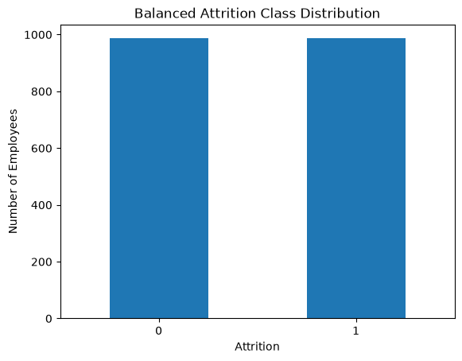
Exploratory Data Analysis (EDA)
Exploratory Data Analysis (EDA) was performed to understand the structure, distribution, and relationships within the employee dataset before applying machine learning algorithms. EDA helps identify important patterns, detect potential issues in the data, and understand factors that may be associated with employee attrition.
Target Variable Analysis
The target variable, Attrition, represents whether an employee leaves the organization. It contains two classes:
- Yes – Employee has left the organization.
- No – Employee has stayed with the organization.
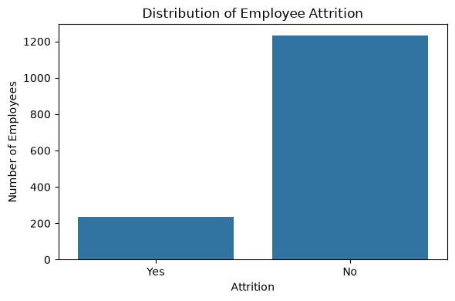
The distribution of these two classes was analyzed to identify whether the dataset was balanced or imbalanced. The analysis showed that the two classes were not equally distributed, indicating a class imbalance problem.
This imbalance was considered during the model development process, and balancing was applied to the training data.
Numerical Feature Analysis
The numerical features were analyzed using descriptive statistics and visualizations to understand their distributions. Features such as age, income, years at the company, years in the current role, and years since the last promotion provide information about employee characteristics and work experience.
Statistical measures such as mean, median, minimum, maximum, and standard deviation were used to understand the numerical variables.
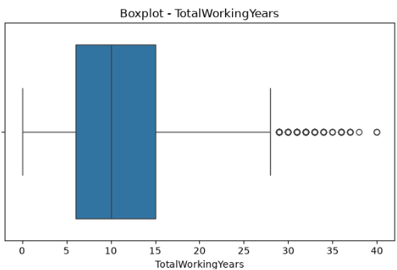
Categorical Feature Analysis
Categorical variables were examined to understand the different groups present in the dataset. Features such as department, job role, business travel, marital status, and overtime provide information about an employee's working conditions and organizational characteristics.
The frequency of different categories was analyzed to identify common and less common groups within the dataset.
Correlation Analysis
Correlation analysis was performed to examine relationships between numerical features. A correlation matrix and heatmap were used to visualize the strength and direction of relationships between variables.
The correlation analysis helped identify features that may have meaningful relationships with employee characteristics and Attrition. It also helped provide insights for feature engineering and subsequent model development.
Key Findings from EDA
The major observations from the exploratory analysis were:
- The target variable Attrition was imbalanced.
- The dataset contained both numerical and categorical features.
- Employee demographic, job-related, compensation, and experience-related attributes showed different distributions.
- Some features were highly related to other features.
- Constant features were identified and later removed during preprocessing.
- The analysis provided a basis for feature engineering and machine learning model development.
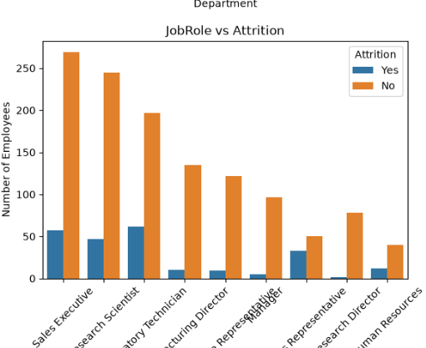
Overall, EDA provided an understanding of the dataset and helped determine the preprocessing and modeling techniques required for employee attrition prediction.

Feature Engineering / Feature Selection
Feature engineering was performed to create additional meaningful information from the existing employee attributes and improve the representation of employee characteristics for the machine learning models.
Current Role Tenure Ratio
The CurrentRoleTenureRatio feature was created to represent the proportion of an employee's total company tenure that has been spent in the current role.
It was calculated using:
CurrentRoleTenureRatio=YearsInCurrentRole / (YearsAtCompany + 1)
The value 1 was added to the denominator to avoid division by zero.
This feature provides an indication of how long an employee has remained in their current position relative to their overall tenure in the organization.
Promotion Gap Ratio
The PromotionGapRatio feature was created using the number of years since the employee's last promotion relative to their total years at the company.
It was calculated using:
PromotionGapRatio=YearsSinceLastPromotion / (YearsAtCompany + 1)
This feature helps represent the relative promotion gap experienced by an employee.
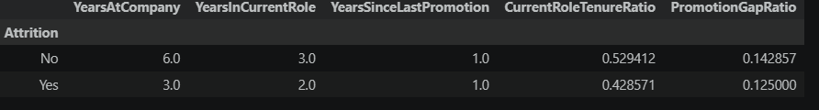
Tenure Group
A categorical feature called TenureGroup was created based on YearsAtCompany.
The employees were divided into five ordered groups:
Tenure Group | Encoding
0-2 Years | 0
3-5 Years | 1
6-10 Years | 2
11-20 Years | 3
20+ Years | 4
This grouping provides a more interpretable representation of employee tenure and allows the model to capture different stages of an employee's time within the organization.
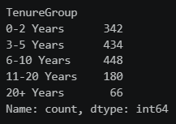
Feature Selection
Constant features were identified because they contained no meaningful variation across the dataset. These features were removed from the modeling process:
- Over18
- StandardHours
- EmployeeCount
Removing these features reduces unnecessary information and helps keep the feature set focused on variables that can contribute to prediction.After feature engineering and feature selection, the resulting feature set was used for encoding, scaling, and machine learning model development.
Model Development
Five supervised machine learning classification algorithms were developed to predict employee Attrition. The models were selected to provide a comparison between different classification approaches.
Logistic Regression
Logistic Regression was used as a baseline classification model for predicting the probability of employee Attrition. It is suitable for binary classification problems and provides an interpretable relationship between input features and the probability of the target class.
Decision Tree
A Decision Tree classifier was developed to make predictions using a sequence of decision rules based on the input features. It can capture nonlinear relationships and is relatively easy to interpret.
Random Forest
Random Forest was used as an ensemble learning method. It combines multiple decision trees and aggregates their predictions to produce the final classification. This approach can capture complex relationships between employee characteristics and Attrition.
Support Vector Machine
Support Vector Machine (SVM) was used to identify an appropriate decision boundary between employees who are likely to leave and those who are likely to stay. SVM is effective for classification problems involving complex feature relationships.
Naive Bayes
Naive Bayes was included as a probabilistic classification model. It applies Bayes' theorem to estimate the probability of each class based on the available employee features.
Model Development Process
Each model was trained using the prepared training dataset. The models were then evaluated on the testing dataset using multiple performance metrics.
The five models developed were:
Logistic Regression → Decision Tree → Random Forest → SVM → Naive Bayes
The performance of these models was compared using Accuracy, Precision, Recall, and F1-Score to identify the most suitable model for employee Attrition prediction.
Experimental Setup
The experimental setup defines the conditions under which the machine learning models were trained, validated, and evaluated. The same preprocessing and evaluation procedure was followed for all models to ensure a fair comparison.
Dataset Split
The dataset was divided into training and testing sets using an 80:20 ratio.
- Training samples: 1,176
- Testing samples: 294
- Total samples: 1,470
- Features used for modeling: 47
The training set was used for model learning, while the testing set was kept separate for evaluating the models on unseen data.
Class Balancing
The target variable Attrition was imbalanced. Therefore, balancing was performed on the training data before model training.The testing data was not balanced because it was reserved for unbiased evaluation.
Feature Scaling
StandardScaler was used to standardize the feature values. The scaler was fitted using the training data and then applied to both training and testing data.
This ensured that the models received features on a comparable scale.
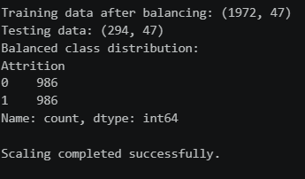
Machine Learning Models
Five classification algorithms were trained and evaluated:
- Logistic Regression
- Decision Tree
- Random Forest
- Support Vector Machine (SVM)
- Naive Bayes
Evaluation Metrics
The models were evaluated using four primary classification metrics:
- Accuracy – measures the overall proportion of correctly classified samples.
- Precision – measures how many predicted positive cases were actually positive.
- Recall – measures how many actual positive cases were correctly identified.
- F1-Score – provides a balance between Precision and Recall.
Since employee Attrition is an imbalanced classification problem, Recall and F1-Score were given particular importance when comparing model performance.
Computational Environment
The experiments were implemented using Python and commonly used machine learning libraries, including Pandas, NumPy, Matplotlib, Seaborn, and Scikit-learn. The experiments were conducted using a Python notebook environment.
Model Validation
Model validation was performed to determine how well the developed machine learning models generalize to unseen employee data. The testing dataset was kept separate from the training process and was used only for evaluating the trained models.
Cross-validation was also considered during the model optimization stage to obtain a more reliable estimate of model performance and to reduce dependence on a single train-validation split.
Cross-Validation
For hyperparameter tuning, 5-fold cross-validation was used with GridSearchCV. The training data was divided into five subsets. The model was trained using four subsets and validated using the remaining subset. This process was repeated until each subset had been used as the validation set.
The final cross-validation score was calculated from the performance across the five folds.
Validation Metric
The F1-Score was used as the primary metric during hyperparameter tuning because the Attrition target variable was imbalanced. F1-Score considers both Precision and Recall and provides a balanced measure of classification performance.
The best cross-validation F1-Score obtained during Logistic Regression tuning was:
Best Cross-Validation F1-Score = 0.7917
The validation process helped identify a suitable model configuration before performing the final evaluation on the unseen testing data.
Hyperparameter Tuning
Hyperparameter tuning was performed to improve the performance of the selected machine learning model. Hyperparameters are settings that control the behavior of a machine learning algorithm and are not learned directly from the training data.
In this study, Logistic Regression was selected for further optimization based on the initial model comparison. GridSearchCV was used to systematically evaluate different combinations of Logistic Regression hyperparameters.
Parameters Tuned
The following parameters were considered:
- C – controls the strength of regularization.
- Solver – specifies the algorithm used to optimize the Logistic Regression model.
Best Parameters
The GridSearchCV experiment identified the following configuration as the best combination:
Parameter | Best Value
C | 0.01
Solver | liblinear
The best configuration achieved a cross-validation F1-Score of 0.7917.
Tuned Model
Using the best parameters, a new Logistic Regression model was trained on the prepared training data. This optimized model was then evaluated on the unseen testing dataset. Hyperparameter tuning helped improve the model's ability to balance Precision and Recall and resulted in an improved final Logistic Regression model for employee Attrition prediction.
Model Evaluation
The developed machine learning models were evaluated on the unseen testing dataset using Accuracy, Precision, Recall, and F1-Score. These metrics were selected to provide a comprehensive assessment of classification performance, particularly because the Attrition target variable was imbalanced.
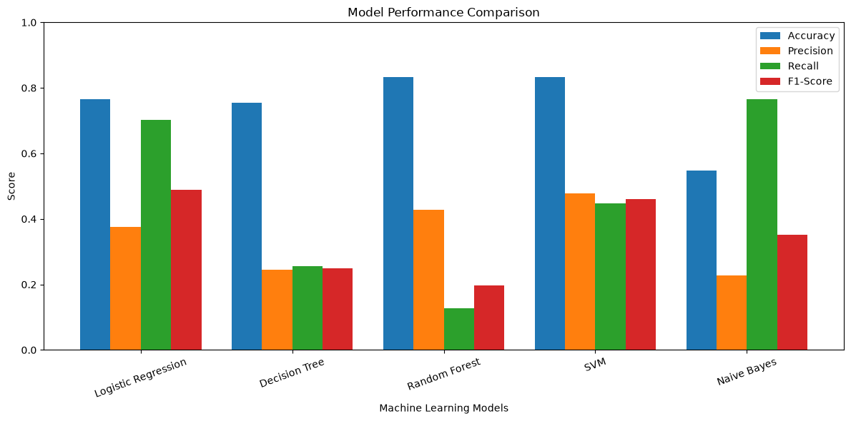
Evaluation Metrics
Accuracy measures the proportion of all predictions that were correctly classified.
Precision measures the proportion of employees predicted as likely to leave who actually belonged to the Attrition class.
Recall measures the proportion of actual Attrition cases that were correctly identified by the model.
F1-Score is the harmonic mean of Precision and Recall and is useful when both measures need to be considered together.
Performance of Initial Models
The performance obtained by the five machine learning models is shown below.
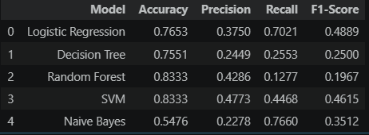
The results show that Random Forest and SVM achieved the highest Accuracy (0.8333). However, Random Forest produced a relatively low Recall and F1-Score for the Attrition class. Logistic Regression achieved a higher Recall and F1-Score than Random Forest and Decision Tree.
Since identifying employees who may leave is an important objective, Accuracy alone was not considered sufficient for selecting the final model. Tuned Logistic Regression
After hyperparameter tuning, Logistic Regression was optimized using the best parameters obtained through GridSearchCV.
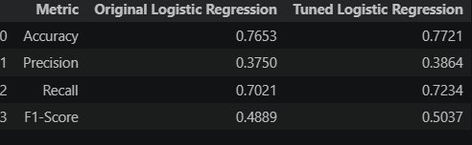
Model Comparison
The performance of the five machine learning models was compared using Accuracy, Precision, Recall, and F1-Score. The comparison helps identify the strengths and weaknesses of each model for employee Attrition prediction.
The Random Forest and SVM models achieved the highest Accuracy of 0.8333. However, Accuracy alone does not provide a complete picture because the dataset contains an imbalanced Attrition target.
Naive Bayes achieved the highest Recall of 0.7660, indicating that it identified a relatively large proportion of actual Attrition cases. However, its Accuracy and F1-Score were comparatively low.
Logistic Regression achieved a Recall of 0.7021 and an F1-Score of 0.4889, providing a better balance between identifying Attrition cases and maintaining overall classification performance.
Decision Tree produced relatively low Precision, Recall, and F1-Score compared with the other models.
Overall, the initial comparison indicated that Logistic Regression was a suitable candidate for further optimization, particularly because of its balance between Precision, Recall, and F1-Score. Hyperparameter tuning was therefore performed to improve its performance.
The comparison of all five models is shown below:
Final Model Selection
Based on the comparison of the five machine learning models, Logistic Regression was selected for further optimization because it provided a comparatively better balance between Precision, Recall, and F1-Score.
Hyperparameter tuning was performed using GridSearchCV with 5-fold cross-validation. The best configuration obtained was:
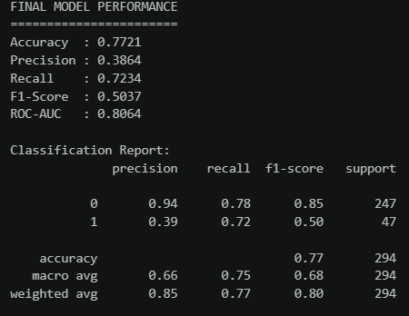
After tuning, the Logistic Regression model showed improvement across the evaluated metrics.
The tuned model achieved higher Accuracy, Precision, Recall, and F1-Score than the initial Logistic Regression model. The improvement in Recall is particularly relevant because correctly identifying employees who may leave is an important objective of attrition prediction.
Therefore, the Tuned Logistic Regression model was selected as the final model for employee Attrition prediction.
Sample / Unseen Data Prediction
After selecting the tuned Logistic Regression model as the final model, it was tested using new employee information that was not used during the model training process.
The purpose of this step was to demonstrate how the final model can be used to predict the Attrition status of an employee based on their characteristics.
The new employee data was processed using the same feature structure and scaling procedure used during model development. The processed input was then provided to the trained Logistic Regression model.
The prediction produces two possible outcomes:
- Attrition = Yes: The employee is predicted to be likely to leave the organization.
- Attrition = No: The employee is predicted to be likely to stay with the organization.
The model also provides an Attrition Probability, which represents the estimated likelihood of the employee belonging to the Attrition class.
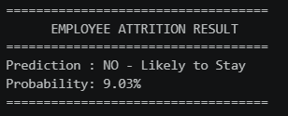
Results
The experimental results demonstrate the performance of different machine learning approaches for employee Attrition prediction. Five classification models were developed and evaluated using the testing dataset.
Among the initial models, Random Forest and SVM achieved the highest Accuracy of 0.8333. However, their Recall and F1-Score for the Attrition class were comparatively lower. Naive Bayes achieved the highest Recall of 0.7660, but its overall Accuracy and F1-Score were lower.
Logistic Regression provided a better balance between Precision, Recall, and F1-Score and was therefore selected for hyperparameter optimization.
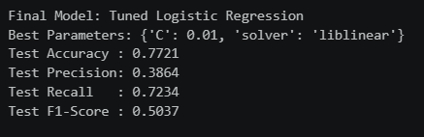
Discussion
The experimental findings show that employee Attrition prediction is influenced not only by the choice of machine learning algorithm but also by preprocessing, feature engineering, class balancing, and hyperparameter optimization.
The initial model comparison showed that Random Forest and SVM achieved the highest Accuracy (0.8333). However, their lower Recall values indicate that high overall accuracy did not necessarily correspond to effective identification of employees belonging to the Attrition class.
Naive Bayes achieved the highest Recall (0.7660) among the initial models, meaning that it identified a larger proportion of actual Attrition cases. However, its relatively low Accuracy (0.5476) and F1-Score (0.3512) indicate weaker overall classification performance.
Logistic Regression produced a comparatively better balance between Precision and Recall. Its initial F1-Score was 0.4889, which was higher than the F1-Scores of Decision Tree, Random Forest, and Naive Bayes.
Hyperparameter tuning further improved Logistic Regression. The tuned model increased its:
The improvement in Recall is particularly important for this study because failing to identify an employee who is likely to leave may be more significant than incorrectly identifying an employee as being at risk.
The results also demonstrate why multiple evaluation metrics should be considered for an imbalanced classification problem. A model with high Accuracy may still have poor performance in identifying the minority Attrition class.
Overall, the findings support the selection of Tuned Logistic Regression as the final model for this study. However, the results should be interpreted as predictive estimates rather than definite statements about whether an individual employee will leave the organization.
Limitations
Although the developed machine learning models provided useful results for employee Attrition prediction, the study has several limitations.
- The dataset contains a limited number of employee records, which may restrict the generalizability of the findings to other organizations or industries.
- The dataset may not represent all factors that influence employee Attrition, such as personal circumstances, management quality, organizational culture, or external employment opportunities.
- The target variable is imbalanced, which can make accurate identification of the minority Attrition class challenging.
- The performance of the models depends on the quality and relevance of the available features.
- Feature engineering in this study was based on the available dataset and may not capture all possible relationships between employee characteristics.
- Only five machine learning algorithms were considered: Logistic Regression, Decision Tree, Random Forest, SVM, and Naive Bayes.
- Hyperparameter tuning was mainly performed for Logistic Regression rather than for all five models.
- The final model provides a prediction of Attrition probability, but the prediction does not guarantee that an employee will actually leave the organization.
- The model was developed using historical employee data, so changes in organizational policies, working conditions, or employee behavior may affect its performance on future data.
- Additional external validation using employee datasets from different organizations would be required to determine how well the model generalizes to other environments.
Conclusion
This study developed a machine learning-based approach for predicting employee Attrition using an employee dataset containing 1,470 records. A complete machine learning workflow was followed, including data preprocessing, exploratory data analysis, feature engineering, class imbalance handling, feature scaling, model development, validation, evaluation, and hyperparameter tuning.
Five classification algorithms—Logistic Regression, Decision Tree, Random Forest, Support Vector Machine (SVM), and Naive Bayes—were developed and compared using Accuracy, Precision, Recall, and F1-Score. The comparison demonstrated that different models provided different strengths, particularly when dealing with the imbalanced Attrition target.
Logistic Regression was selected for further optimization because it provided a comparatively balanced performance across the evaluation metrics. GridSearchCV with 5-fold cross-validation was used for hyperparameter tuning, resulting in C = 0.01 and solver = liblinear, with a best cross-validation F1-Score of 0.7917.
The tuned Logistic Regression model achieved an Accuracy of 0.7721, Precision of 0.3864, Recall of 0.7234, and F1-Score of 0.5037 on the evaluation data. The improvement over the initial Logistic Regression model demonstrates the benefit of hyperparameter optimization.
The final model was also used to perform prediction on new employee information. Overall, the study demonstrates that machine learning can be used as a data-driven approach for employee Attrition prediction and can provide useful insights into identifying employees who may be at higher risk of leaving an organization. However, the predictions should be interpreted carefully and should complement, rather than replace, organizational and human resource decision-making.
Future Scope
The employee Attrition prediction system can be further improved and extended in several ways:
- Larger and diverse datasets: Employee data from multiple organizations and industries can be incorporated to improve the generalizability of the model.
- Advanced machine learning algorithms: Additional models such as Gradient Boosting, XGBoost, LightGBM, and ensemble techniques can be explored and compared.
- Advanced feature selection: Feature selection and dimensionality-reduction techniques can be applied to identify the most influential variables and reduce unnecessary features.
- Explainable AI: Techniques such as SHAP and LIME can be incorporated to explain why a particular employee is predicted to have a higher likelihood of Attrition.
- Improved class imbalance techniques: Other approaches such as SMOTE, ADASYN, and class-weighting methods can be evaluated to improve minority-class prediction.
- Cross-organization validation: The final model can be tested on datasets from different organizations to evaluate its ability to generalize to unseen environments.
- Continuous model improvement: The model can be periodically retrained using new employee data to adapt to changes in workforce behavior and organizational conditions.
- More employee-related features: Additional information such as employee engagement, performance trends, workload, absenteeism, training participation, and organizational satisfaction could improve prediction quality.
- Model interpretability and fairness: Future work can investigate whether predictions are consistent and fair across different employee groups and ensure that the model is used responsibly.
These improvements could make employee Attrition prediction more robust, interpretable, and useful for future research and organizational decision-making.
Reference
- IBM. IBM HR Analytics Employee Attrition & Performance Dataset. Kaggle.
- James, G., Witten, D., Hastie, T., & Tibshirani, R. (2021). An Introduction to Statistical Learning: With Applications in R. Springer.
- Pedregosa, F., et al. (2011). Scikit-learn: Machine Learning in Python. Journal of Machine Learning Research, 12, 2825–2830.
- Han, J., Kamber, M., & Pei, J. (2012). Data Mining: Concepts and Techniques. Morgan Kaufmann.
- Hastie, T., Tibshirani, R., & Friedman, J. (2009). The Elements of Statistical Learning. Springer.
- Breiman, L. (2001). Random Forests. Machine Learning, 45, 5–32.
- Cortes, C., & Vapnik, V. (1995). Support-vector networks. Machine Learning, 20, 273–297.
- Pedregosa, F., et al. (2011). Scikit-learn: Machine Learning in Python. Journal of Machine Learning Research, 12, 2825–2830.
- Géron, A. (2022). Hands-On Machine Learning with Scikit-Learn, Keras & TensorFlow. O'Reilly Media.
- Kuhn, M., & Johnson, K. (2013). Applied Predictive Modeling. Springer.
Appendix
The Appendix contains the supporting material used during the development and evaluation of the employee Attrition prediction model. It provides additional details that support the methodology and experimental results presented in the main report.
Dataset and Preprocessing
The final dataset used for model development contained 1,470 employee records. After preprocessing and feature engineering, 47 features were used for modeling.
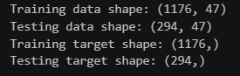
Constant features removed during preprocessing:
- Over18
- StandardHours
- EmployeeCount
Feature Engineering
The following additional features were created:
- CurrentRoleTenureRatio
- PromotionGapRatio
- TenureGroup
TenureGroup was encoded according to the following order:
Tenure Group |  | Encoded Value
0-2 Years | 0
3-5 Years | 1
6-10 Years | 2
11-20 Years | 3
20+ Years | 4
Machine Learning Models
The following five classification models were implemented:
- Logistic Regression
- Decision Tree
- Random Forest
- Support Vector Machine
- Naive Bayes
Hyperparameter Tuning
GridSearchCV with 5-fold cross-validation was applied to Logistic Regression.

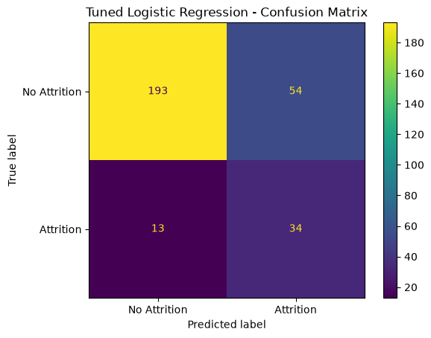
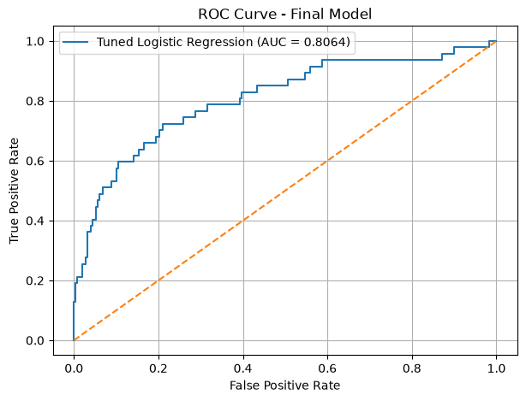
Final Prediction
The final tuned Logistic Regression model was used to predict the Attrition status of new employee information. The prediction produces:

